# Mechanical Components – Preliminary Research

The mechanical components make up the physical system including, but not necessarily limited to:

* Input of materials to be identified/sorted
* Output of identified/sorted materials
* Actuators involved in moving the material through the intermediate/identification stage

## Factors to Consider First

### 1.1 Average Weight of Recyclables/Trash

How much weight does this system need to support/transport (aside from supporting functional components and housing)?

* Avg weight of plastic (single-use) waterbottle: 9.25 g [1]
* Avg weight of empty AT2 glass bottle (standard beer bottle): 275 g [2]
* Avg weight of empty pizza box: 153 g [3]
* Avg weight of empty soup can: 13.11 g [4]

Useful quick reference weights for some common recyclables: <https://www.aspower.com/aspaweb/bids/RFP%20NO.%20ASPA14.1216%20ASPA%20AND%20PUBLIC%20JOINT%20VENTURE%20RECYCLING-Appendix%20A.pdf> [4]

It is likely that glass bottles will be the heaviest materials that need to be transported. For the purpose of this preliminary research, I will assume that the largest mass of recyclables that needs to be moved at any moment does not exceed 500 g.

### 1.2 Gentleness of the System

At least in the region of Waterloo, broken glass is not recyclable [5]. This is to ensure the safety of the workers handling the recyclables [5]. For simplicity, I will assume that no broken glass is entering the system. However, because of potential safety concerns/recycling regulations, the system should also handle the materials with enough gentleness that no glass breaks during the identification/sorting process. This can affect which input/output/sorting mechanisms are viable, and details such as rpm in motor selection/control.

## Component Research

### 2.1 Motors

Motor requirements will rely heavily on how the motor is being implemented (for linear translation, rotary, what other components is it working with, etc.) so this research will provide a general overview of some commonly available small electric motors.

For a mass of 1 kg at a distance of 15 cm (a rough worst-case scenario based on a large mass concentrated on the center of a 30 cm long motorized flap – this will be refined when an actual design/motor configuration is selected), we need a minimum torque of approximately:

$$T=0.5 kg ×9.81 m/s^{2}×0.15 m =0.73575 Nm=735.75 mNm$$

To keep prices moderate, this torque will have to be achieved with a speed reduction (gears).

Some sample DC motors:

|  |  |  |  |  |  |  |
| --- | --- | --- | --- | --- | --- | --- |
| Model Name | Brand | Speed (rpm) | Torque (Nm) | Power (W) | Unit Price | Source |
| 22N28-216E.286 | Digi-Key | 10000 | 0.0084 | 3.8 | $64.98 | [6] |
| 755-19175-C | Transmotec | 3900 | 0.0336 | 14 | $60.30 USD | [7] |
| 775-9009F-C-CC | Transmotec | 18000 | 0.1026 | 194 | $61.30 USD | [8] |

### 2.2 Linear Actuators

Below taken from [9].

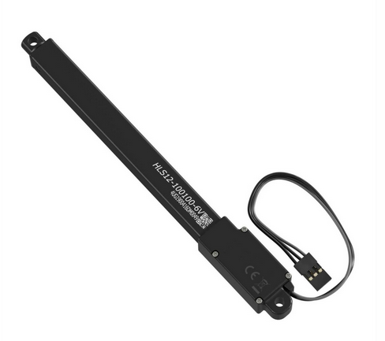

* 100 mm stroke
* $133.32 CAD
* Max force (lifted): Load = 4.2 kg, Speed = 3.2 mm/s

Below taken from [10].

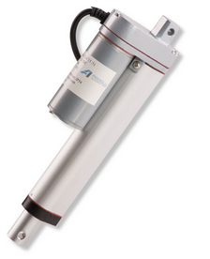

* 24” stroke
* $146.65 CAD
* Force: 150 lbs

Below taken from [11].

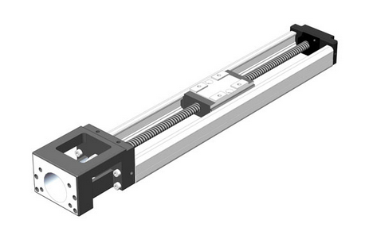

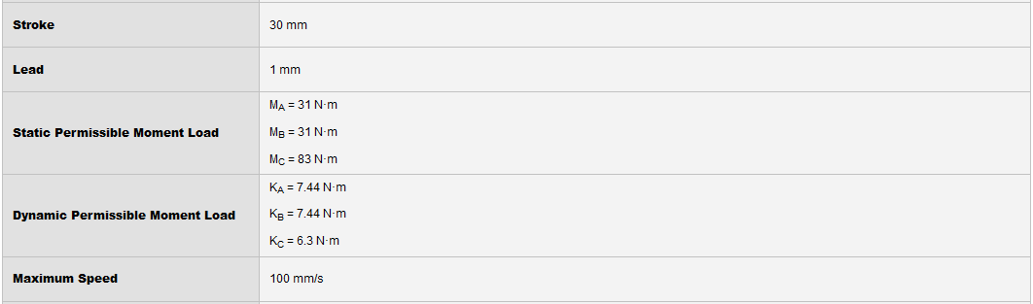

* $602.65
  + Expensive, but we can use the same principles and make our own

### 2.3 Pneumatic/Hydraulic Actuators

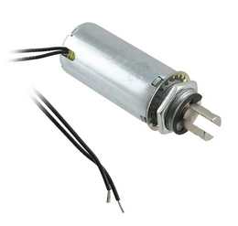

* Pneumatic
* $52.27
* 19.05 mm stroke length
  + Likely way too small to be useful
  + Difficult to find reliable pricing for longer stroke lengths
* <https://www.digikey.ca/en/products/detail/pontiac-coil-inc/F0483A/668315>

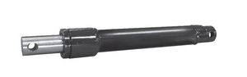

* Hydraulic
* $75.91
* 6 inch (?) stroke length
* <https://www.baileyhydraulics.com/Cylinders-for-Snowplow-Applications-Double-Ports>

### 2.4 Grabbers

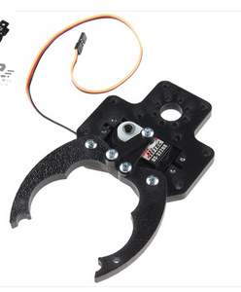

* $13.99
* <https://www.robotshop.com/ca/en/actobotics-horizontal-standard-gripper-kit-a.html>
* Can grab items up to 4.20” wide

### 2.5 Other

An assortment of various power transmission components we can make use of.

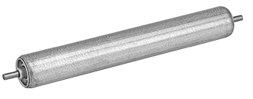

¾” Diameter conveyor roller

* $8 each
* 30 lbs capacity
* <https://www.mcmaster.com/2278T11/>

# Quick References

|  |  |
| --- | --- |
| [1] | https://www.recyclingtoday.com/article/water-bottle-weight-decreases-recycled-content-increases/ |
| [2] | https://unitedbottles.com/product/canadian-isb-341-ml-at2p |
| [3] | https://www.maarslet-pizza.dk/w-pizza/weight-of-pizza-box.html |
| [4] | https://www.aspower.com/aspaweb/bids/RFP%20NO.%20ASPA14.1216%20ASPA%20AND%20PUBLIC %20JOINT%20VENTURE%20RECYCLING-Appendix%20A.pdf |
| [5] | https://www.regionofwaterloo.ca/en/living-here/my-waste-app.aspx#!rc-cpage=487148 |
| [6] | https://www.digikey.ca/en/products/detail/portescap/22N28-216E-286/5232871 |
| [7] | https://transmotec.com/product/755-19175-C/ |
| [8] | https://transmotec.com/product/775-9009F-C-CC/ |
| [9] | https://www.robotshop.com/ca/en/hitec-hls12-series-6v-linear-actuator-100mm-1001.html |
| [10] | https://www.robotshop.com/ca/en/firgelli-24-150lb-linear-actuator.html?gclid=EAIaIQobChMIwJ7Ki-jO7gIVGL3ICh395QlgEAYYAyABEgLUNPD_BwE |
| [11] | <https://catalog.orientalmotor.com/item/linear-actuators-linear-slides-only/shop-thk-linear-slides-actuators/kr2001a-0030-0-01a0> |